EDA of Abalone Data for Age predictors
Let us first look at a simple pairwise correlation matrix to find out any relationships between the different physical properties. One of the fields is “Sex” which is non-numeric so we use Polychorric correlation.
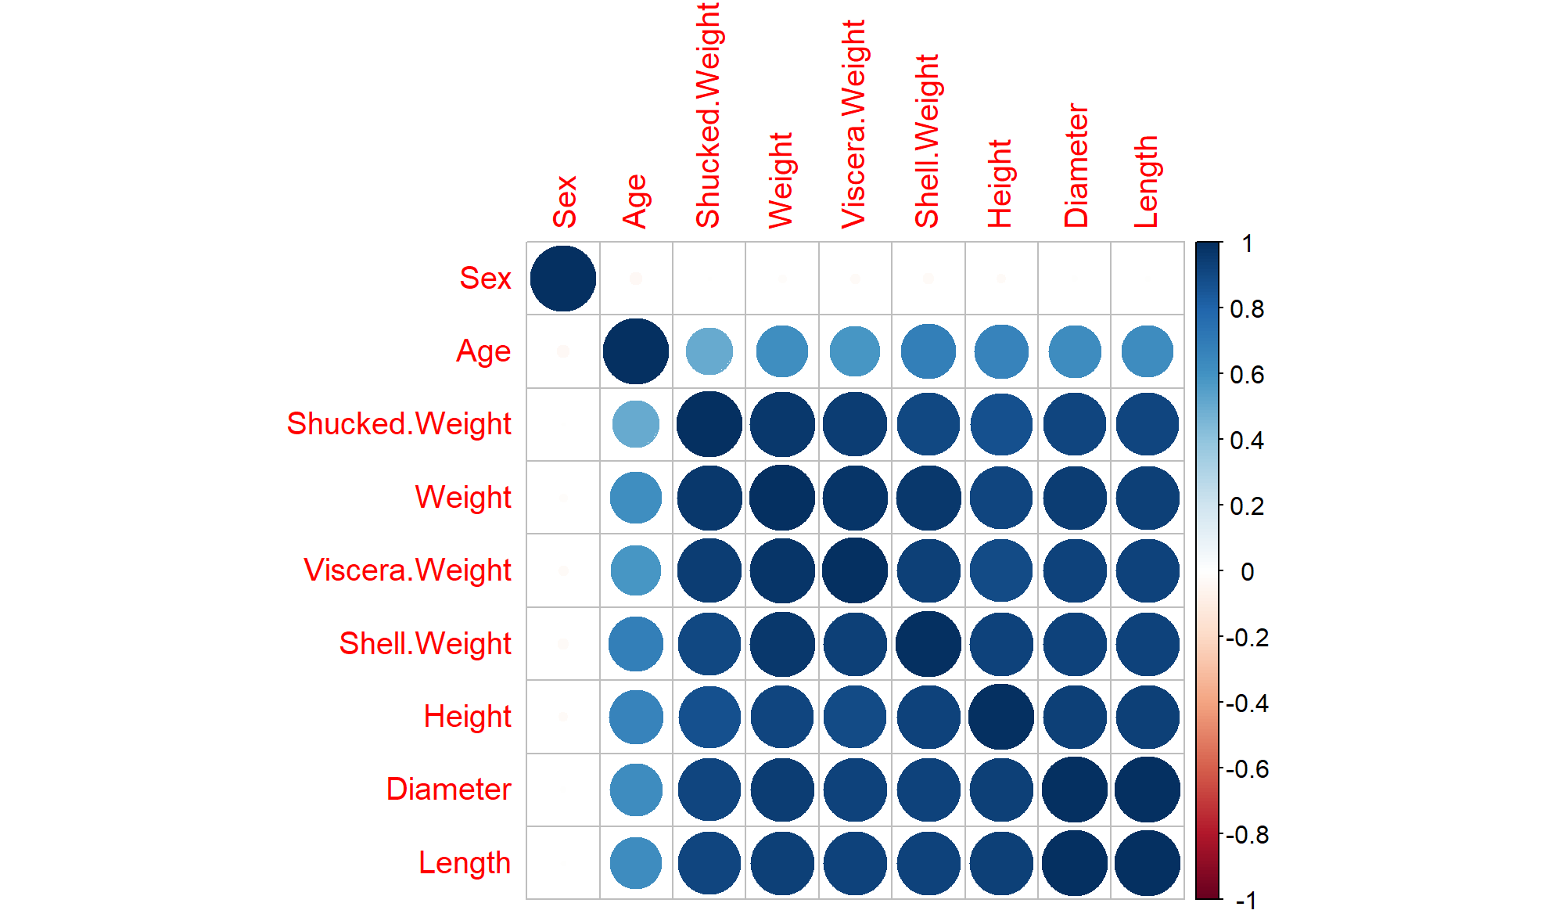
The plot shows significant relationships in the data.
We are interested in predicting Age, so we can see that Age is correlated to a bunch of properties but “Shell.Weight” has the strongest correlation. Interestingly “Sex” has no correlation with any of the physical properties.
Let’s try to fit a few Linear regression models using the different physical properties to assess which would be a good predictor for Age. The following chart shows the combinations of physical properties and their Mean Absolute Error. Most of the models are using multiple linear regression:
Model properties | MAE
Shell.Weight + Height + Diameter + Length | 1.602323
Shell.Weight | 1.629775
Shell.Weight + Viscera.Weight | 1.583133
Shell.Weight + Viscera.Weight + Shucked.Weight | 1.496068
Shell.Weight + Height + Diameter + Shucked.Weight | 1.460799

The MAE was computed by using a 70:30 train-test split on the data with a random seed of 5 and using the mae() function from the Metrics package.
The last combination has the lowest MAE. However, it is possible that this last model is not yet the complete story. It assumes that the physical properties used as predictor variables are independent. Considering domain knowledge, it appears that the weight, height and diameter properties should be related. Larger molluscs should also weight more. To account for this non-independence of predictor variables in our model, we can specify an interaction term, which is calculated as the product of the predictor variables:
Age ~ Intercept + Slope1(Shell.Weight) + Slope2(Height) + Slope3(Diameter) + Slope4(Shucked.Weight) + Slope5(Shell.Weight * Height * Diameter * Shucked.Weight) + Error
Shell.Weight * Height * Diameter * Shucked.Weight | 1.423879

This provides us with the lowest MAE so far. Now let’s look at how well the model fits the data. We can plot the histogram of the residuals.
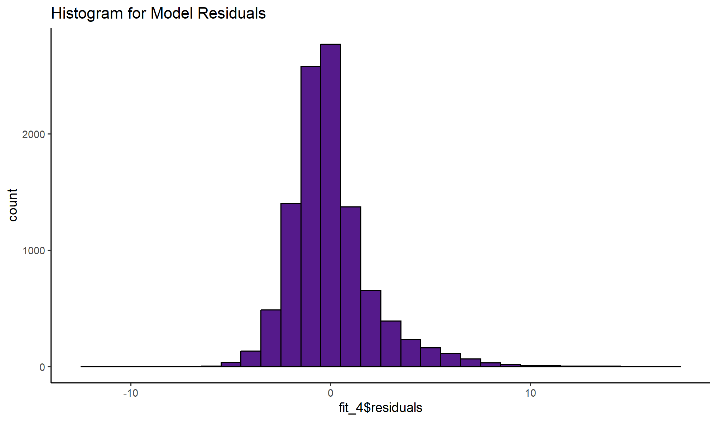
As is clear the plot is very close to a normal curve around 0 suggesting that the model fits the data well.
Summary data for the model:
Call:
lm(formula = Age ~ Shell.Weight * Height * Diameter * Shucked.Weight,
data = train)
Residuals:
Min 1Q Median 3Q Max
-12.4987 -1.2335 -0.3201 0.7528 17.3561
Coefficients:
Estimate Std. Error t value Pr(>|t|)
(Intercept) 3.75966 0.63909 5.883 4.16e-09
Shell.Weight 0.26351 0.61361 0.429 0.66761
Height 8.69388 3.76048 2.312 0.02080
Diameter -1.54160 1.85414 -0.831 0.40575
Shucked.Weight 0.82522 0.20619 4.002 6.32e-05
Shell.Weight:Height 7.94326 1.52998 5.192 2.12e-07
Shell.Weight:Diameter 0.93503 0.48512 1.927 0.05395
Height:Diameter -2.81362 6.26074 -0.449 0.65315
Shell.Weight:Shucked.Weight -0.18472 0.06680 -2.765 0.00570
Height:Shucked.Weight -4.10455 0.84047 -4.884 1.06e-06
Diameter:Shucked.Weight -0.73509 0.24091 -3.051 0.00228
Shell.Weight:Height:Diameter -6.30589 1.03894 -6.070 1.33e-09
Shell.Weight:Height:Shucked.Weight 0.13170 0.13264 0.993 0.32077
Shell.Weight:Diameter:Shucked.Weight 0.11891 0.03989 2.981 0.00288
Height:Diameter:Shucked.Weight 3.29522 0.63987 5.150 2.65e-07
Shell.Weight:Height:Diameter:Shucked.Weight -0.10462 0.07644 -1.369 0.17110
---
Signif. codes: 0 ‘***’ 0.001 ‘**’ 0.01 ‘*’ 0.05 ‘.’ 0.1 ‘ ’ 1

Residual standard error: 2.114 on 10484 degrees of freedom
Multiple R-squared: 0.5868, Adjusted R-squared: 0.5862
F-statistic: 992.5 on 15 and 10484 DF, p-value: < 2.2e-16

